
East West University
Department of Computer Science and Engineering

A/2, Jahurul Islam Avenue, Jahurul Islam City, Aftabnagar, Dhaka

Lab Manual: 04
Lab Topic: String and Two-Dimensional Array Manipulations
Course Code: CSE110 (Object Oriented Programming)
Course Instructor: Tanni Mittra, Senior Lecturer, CSE

Lab Objective
- Apply concepts of two dimensional arrays and String
- Write and execute programs using these concepts in Java.

Lab Problems

01: Write a program that randomly fills in 0s and 1s into a 4-by-4 matrix, prints the matrix, and finds the first row and column with the most 1s. Here is a sample run of the program:

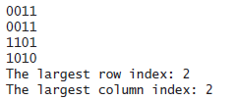

02: Write a method that checks whether a string is a valid password. Suppose the password rules are as follows:
- A password must have at least eight characters.
- A password consists of only letters and digits.
- A password must contain at least two digits.
Write a program that prompts the user to enter a password and displays Valid Password if the rules are followed or Invalid Password otherwise.

03: Suppose the weekly hours for all employees are stored in a two-dimensional array. Each row records an employee’s seven-day work hours with seven columns. For example, the following array stores the work hours for eight employees. Write a program that displays employees and their total hours in decreasing order.

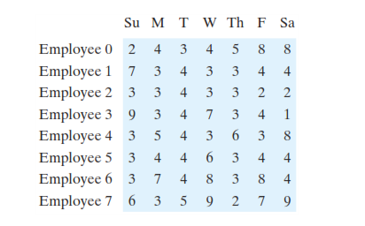

04: Write a java program to Sort N number of strings entered by keyboard in Lexicographical Order (Dictionary Order).

Enter 5 words: R programming
JavaScript
Java
C programming
C++ programming

In the lexicographical order:
C programming
C++ programming
Java
JavaScript
R programming

05: Write a program to sort a two-dimensional array according to the values in any given column

Input: If our 2D array is given as (Order 4X4)
39 27 11 42
10 93 91 90
54 78 56 89
24 64 20 65
Sorting it by values in column 3
Output: 39 27 11 42
24 64 20 65
54 78 56 89
10 93 91 90

